**Phase 5: Image Recognition with IBM Cloud Visual Recognition**

Introduction:

**Project Objectives:**

The creation of a flexible image recognition system is the main goal of the IBM Cloud Image Recognition Project. Users can input photographs, classify them properly, and create insightful captions with this system. The ultimate goal of this project is to improve user experience through the facilitation of compelling visual storytelling and the development of deeper relationships with the audience.

**Design Thinking Process:**

**Phase 1: Project Definition and Design Thinking:**

* Set clear project goals and objectives.
* Defined success criteria for project completion.
* Established IBM Cloud Visual Recognition service with the acquisition of necessary API keys.
* Initiated the design of a user-friendly interface for image uploads and AIgenerated captions.

**Phase 2: Innovation:**

Evaluated the potential of incorporating sentiment analysis to generate emotionally rich image captions.

**Phase 3: Development Part 1:**

• Started utilizing IBM Cloud Visual Recognition to construct the picture recognition system.

• Sentiment analysis that is integrated for emotionally charged captions.

• Added sophisticated tools for user interaction, like comments, image rating, and social media sharing.

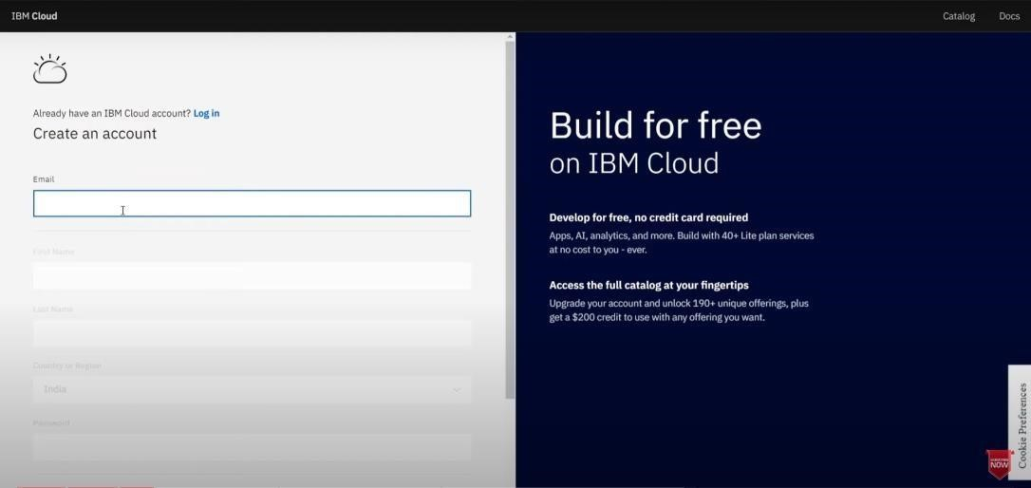

**Phase 4: Development Part 2:**

* Integrated sentiment analysis to enhance caption generation.
* Completed setup on IBM Cloud, Watson Studio integration, and employed pre-built and custom models for image classification.

Phase 5: Documentation:

* Created comprehensive documentation outlining project objectives, design thinking, development phases, platform details, and deployment instructions.

* Designed a detailed README file to guide users on website navigation, content updates, and dependencies.

**Platform Details:**

**Users can post photographs with ease thanks to the platform's user-friendly interface design. The system uses natural language generation for AI-generated captions and IBM Cloud Visual Recognition for image classification upon upload. Crucial elements consist of:**

**• IBM Cloud Visual Recognition for image classification.**

**• Sentiment analysis integration for emotionally charged captions.**

**• Features that encourage user interaction, such as comments, image rating, and social media sharing.**

**Deployment Instructions:**

To deploy the platform on IBM Cloud Foundry, follow these steps:

1. Clone the project's GitHub repository to your local machine.
2. Set up an IBM Cloud account or log in if you already have one.
3. Create an instance of the IBM Cloud Foundry application.
4. Configure the necessary environment variables and credentials.
5. Deploy the application to IBM Cloud Foundry.
6. Access the deployed platform through the provided URL.

For more detailed deployment instructions, refer to the project's README.

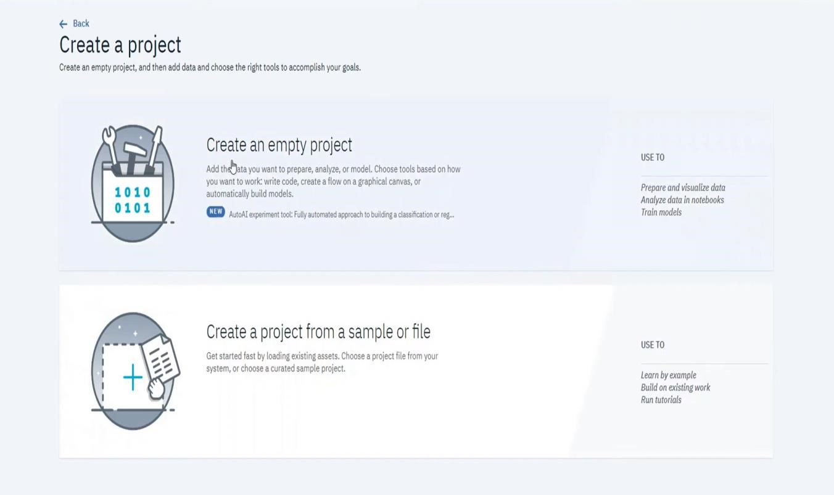

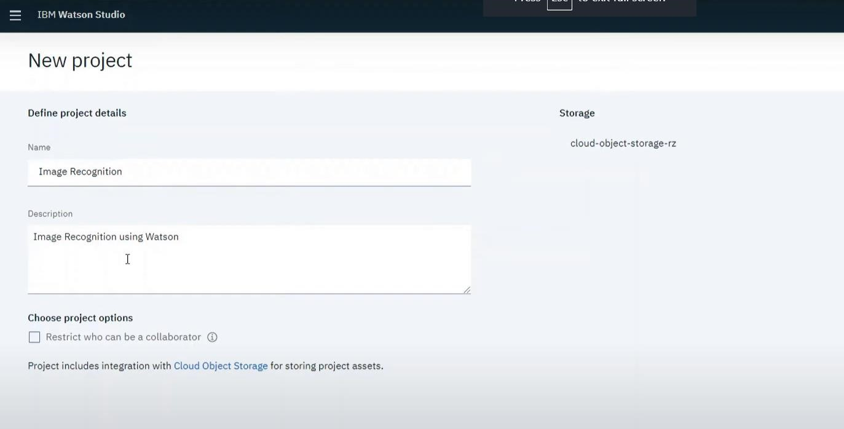

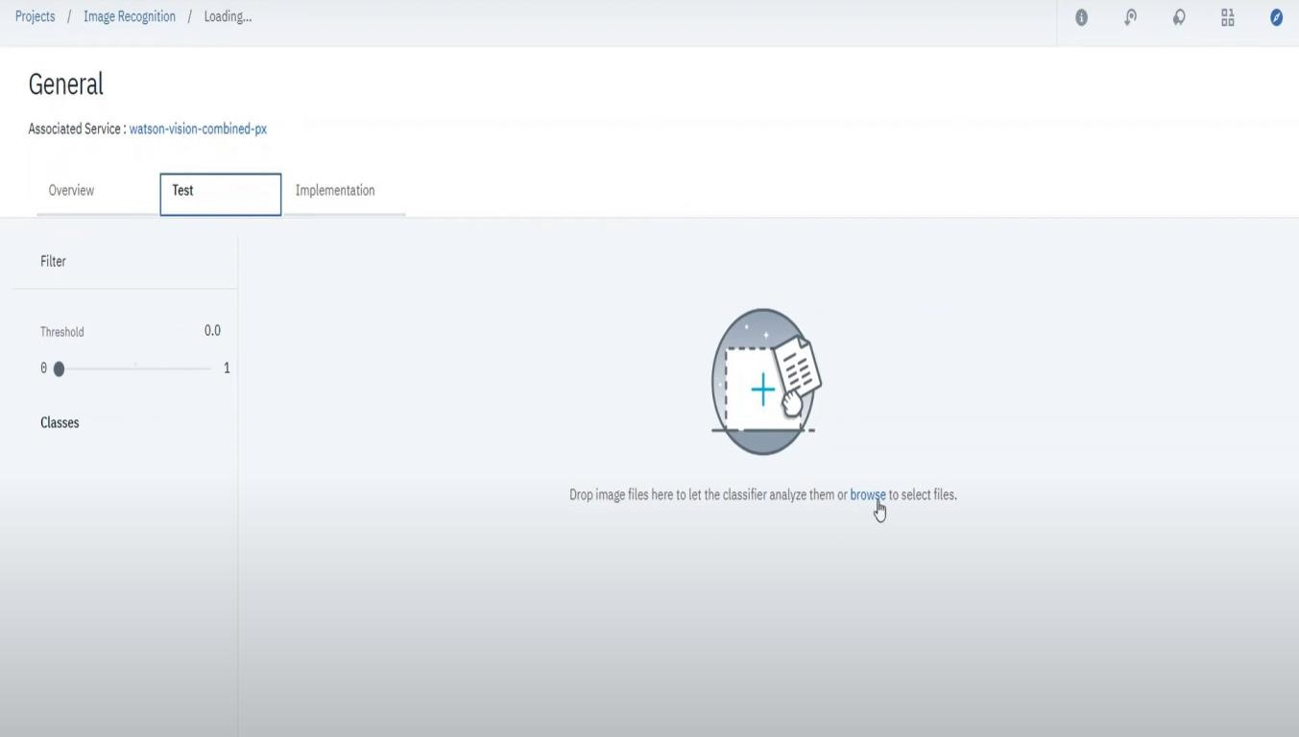

Use minimum of 10 images to get best results:

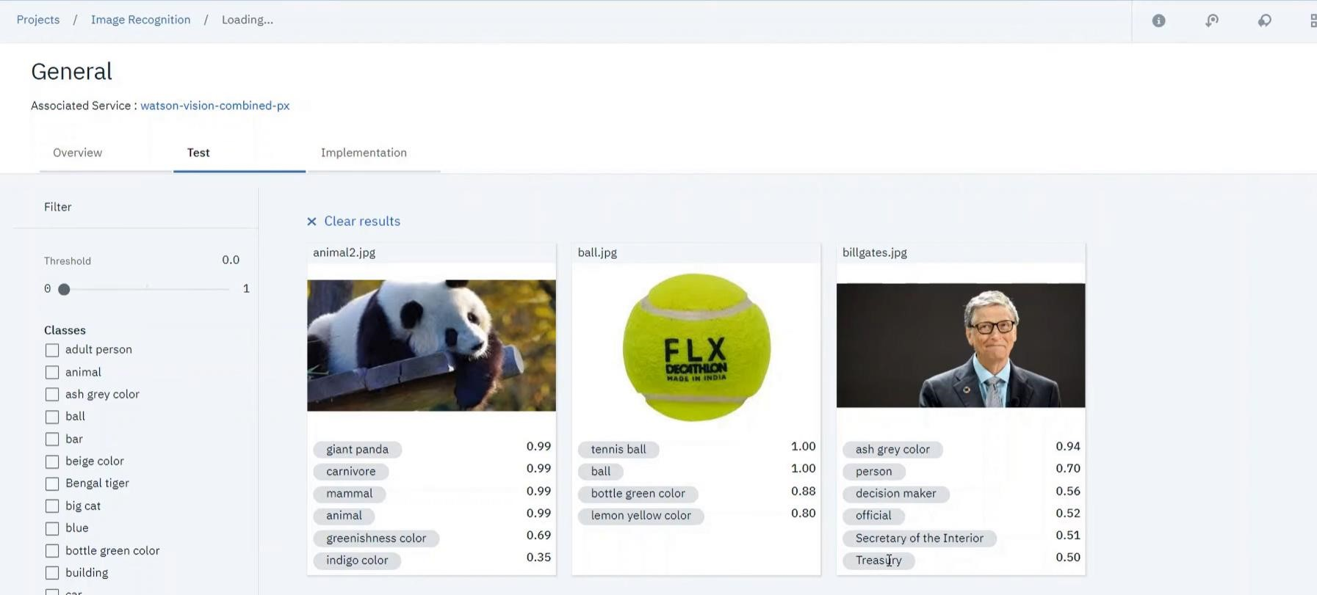

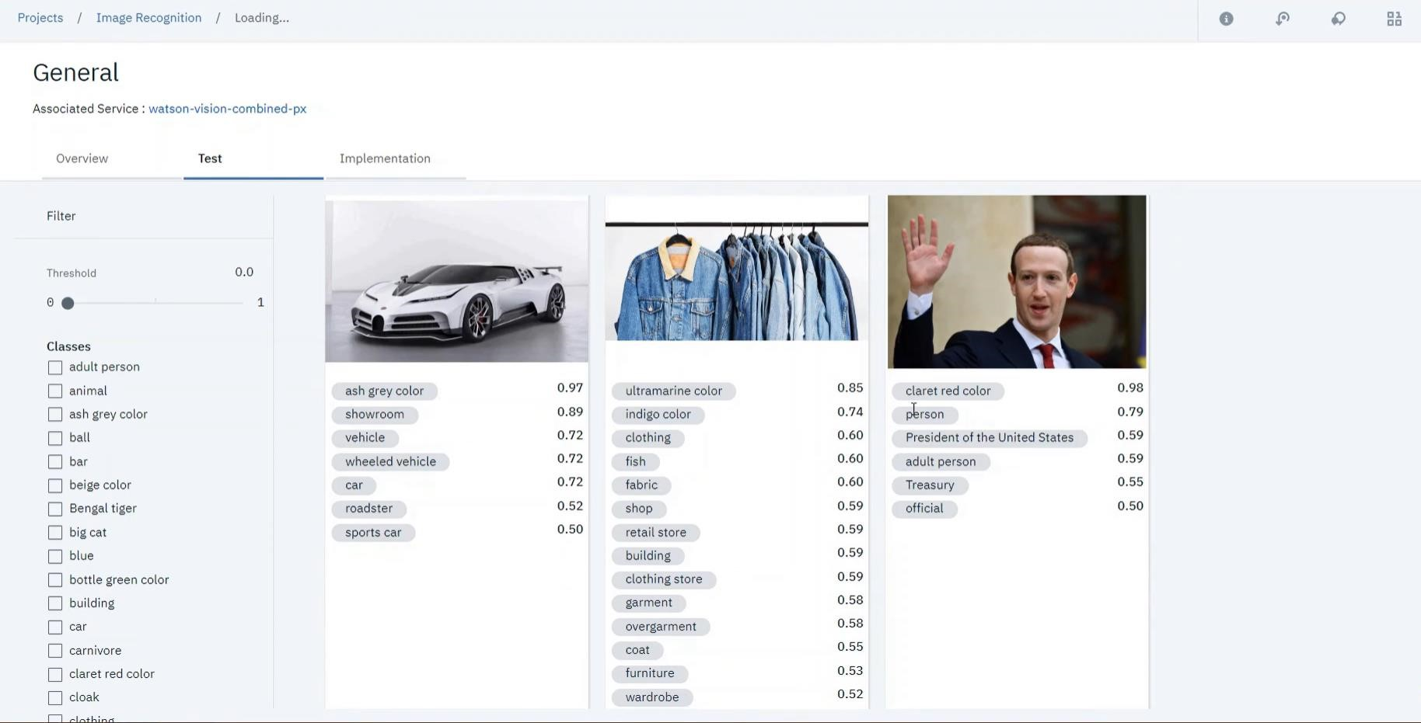

**README Content:**

**The README file for the project offers a thorough how-to on:**

**Using the website's navigation.**

**• Managing user-generated data and content updates.**

**• Instructions for setup and dependencies.**

**Please refer to the README file for the project for a comprehensive understanding.**

**GITHUB Repository:**

**The project’s code and files are available in the**

https://github.com/Antony-Bharat/CAD_phase-1/blob/main/CAD_Website.zip

Conclusion:

**The project's goals, design thinking methodology, development stages, platform specifics, deployment guidelines, GitHub repository, and a README guide for users and contributors are all clearly explained in Phase 5, which concludes the documentation.**